**Reproduction in Feline**

Female cats (called "queens") are termed "seasonally polyestrus." Cats are "long day breeders" and require 12 hours or more of light to maintain normal cyclicity. Long haired breeds tend to be more seasonal than short-haired breeds.

**Puberty**

Puberty in the cat usually occurs at 9 to 10 months of age. Puberty may occur as early as 4 months or as late as 2 years.

**Breeding season:** is from March to September. Actually split seasons with January to March and August to October. Queen is anestrous during late fall and winter. Household queens can cycle during winter with lights in house giving 12 to 14 hours of light.

**Estrous cycle of queen**

Average length of the estrous cycle is 14 to 21 days. The phases of the feline estrous cycle are identified as:

* **Proestrus**
* **Estrus**
* **Interestrus**
* **Diestrus or pseudopregnancy**
* **Anestrus.**

**Proestrus**

the period preceding estrus, lasts 1 to 2 days. During this time, the female is attractive to but not willing to accept the male. Behavioral changes may begin to be seen during proestrus. The queen may rub against objects, vocalize, and assume a lordotic posture(breeding position) (Female crouches, stamps hind feet and raises pelvis) but still rejecting male.

**Estrus**

Estrus is defined as the period of sexual receptivity, lasts 3 to 16 days, with average 7 days. There is Increase intensity of proestrus activity

but will now accept male. Acceptance allows mating with deviation of tail to one side and permission of Tom to grasp her neck , mount and copulate.

**Interestrus**

Interestrus is the period between successive estrus periods if ovulation does not occur. If the queen is not bred, she will cycle into estrus on an average of every 2 to 3 weeks.

**Diestrus or pseudopregnancy**

If the queen ovulates, corpora lutea are formed and secrete progesterone. Elevated progesterone levels are the hallmark of diestrus. If the queen is not pregnant, diestrus is also termed pseudopregnancy and lasts for 35 to 40 days.

Therefore we can define **pseudopregnancy** as a case in which a Sterile mating induces ovulation of follicles and formation of CL release progesterone which is maintained for 35-40 days.

**Note**:If a queen is mated, and conception occurs, the pregnancy will happen and lasts for 60-65 days.

**Anestrus**

is typically seen in the short days of winter. During this time, the queen does not go through any "heats." The tom is not attracted to the queen, and vice versa.

**Copulation procedure**

The tip of the erected penis of tom has **sharp spines**. These cause an intense stimulation of the female’s vagina and that leads to ovulation, mating itself takes less than ten seconds. The tom will ejaculate, and the queen will make a frightening call (copulatory cry) caused by the spines of the penis.

**Time of Ovulation**

Ovulation reportedly occurs 24 to 60 hours post coitus and may vary depending on the mating pattern. Progesterone levels in the blood can be used to verify ovulation. Concentrations of progesterone greater than 1 ng/ml are considered indicative of ovulation. Peak levels of 35 ng/ml in the pregnant queen and 24 ng/ml in the pseudopregnant queen are observed at approximately day 21 post coitus.

Because ovulation is not always triggered by a single mating, females may not be impregnated by the first male with which they mate.  Furthermore, cats are [**superfecund**](http://en.wikipedia.org/wiki/Superfecundation); that is, a female may mate with more than one male when she is in heat, with the result that different kittens in a litter may have different fathers.

**Breeding and Mating Behavior**

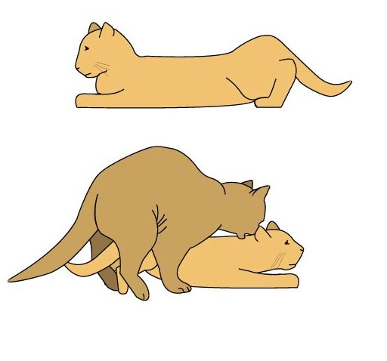



* Male detects female through pheromones.
* Female deviates tail to one side and male bites back of neck to insert penis.
* When penis is withdrawn, female will move forward and give out the “copulation cry”.
* The copulation cry is thought to be caused by the penial spines.
* Breeding is repeated several times.